**ASSIGNMENT-10**

**Q1.Write and explain the program for memory allocation by First Fit, Best and Worst fit.**

**FIRST FIT:-**

#include<stdio.h>

int main(){

int p,m;

printf("Enter number of processes:");

scanf("%d",&p);

printf("\nEnter number of Memory blocks:");

scanf("%d",&m);

int parr[p],marr[m],i;

for(i=0;i<p;i++)

{

printf("\nEnter size of process %d:",i+1);

scanf("%d",&parr[i]);

}

for(i=0;i<m;i++)

{

printf("\nEnter size of memory %d:",i+1);

scanf("%d",&marr[i]);

}

int j;

for(i=0;i<p;i++){

for(j=0;j<m;j++){

if(marr[j]>=parr[i]){

marr[j]-=parr[i];

printf("\nAllocating process %d to memory %d\nSize remaining in it after allocation %d\n\n",i+1,j+1,marr[j]);

break;

}

}

if(j==m)

{printf("\nNot enough memory for process %d",i);break;}

}

return 0;

}

**OUTPUT-**

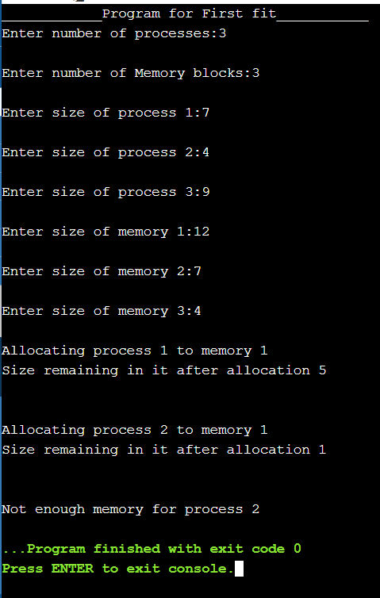

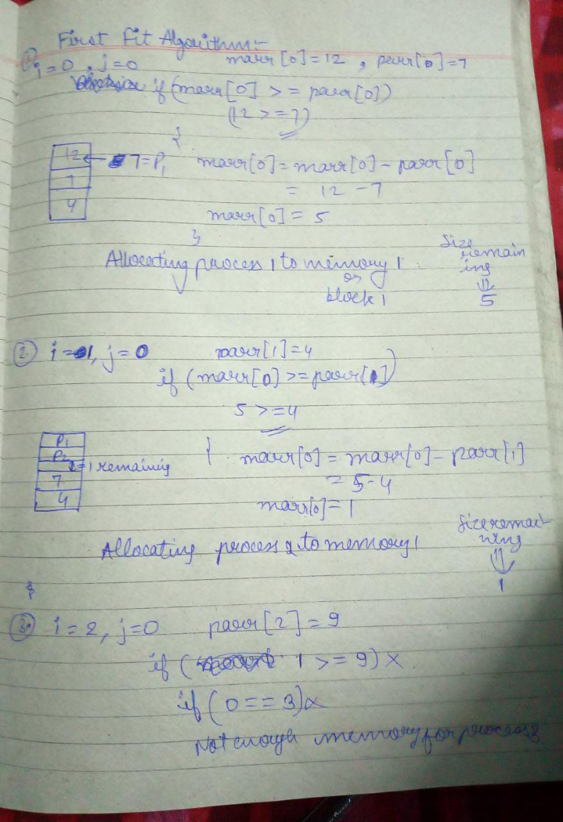

**BEST FIT:-**

#include<stdio.h>

void main()

{

int fragment[20],b[20],p[20],i,j,nb,np,temp,lowest=9999;

static int barray[20],parray[20];

printf("\n_________________ Program for Best Fit__________________");

printf("\nEnter the number of blocks:");

scanf("%d",&nb);

printf("Enter the number of processes:");

scanf("%d",&np);

printf("\nEnter the size of the blocks:-\n");

for(i=1;i<=nb;i++)

{

printf("Block no.%d:",i);

scanf("%d",&b[i]);

}

printf("\nEnter the size of the processes :-\n");

for(i=1;i<=np;i++)

{

printf("Process no.%d:",i);

scanf("%d",&p[i]);

}

for(i=1;i<=np;i++)

{

for(j=1;j<=nb;j++)

{

if(barray[j]!=1)

{

temp=b[j]-p[i];

if(temp>=0)

if(lowest>temp)

{

parray[i]=j;

lowest=temp;

}

}

}

fragment[i]=lowest;

barray[parray[i]]=1;

lowest=10000;

}

printf("\nProcess_no\tProcess_size\tBlock_no\tBlock_size\tFragment");

for(i=1;i<=np && parray[i]!=0;i++)

printf("\n%d\t\t%d\t\t%d\t\t%d\t\t%d",i,p[i],parray[i],b[parray[i]],fragment[i]);

}

**OUTPUT-**

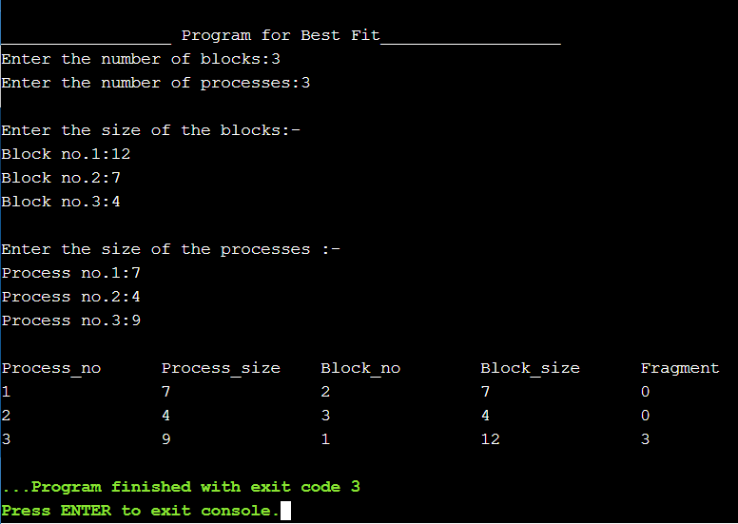

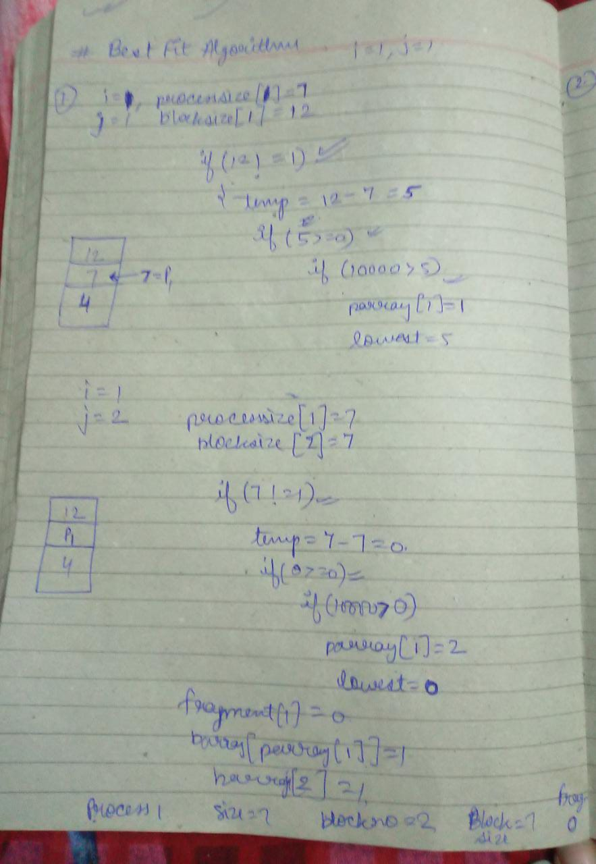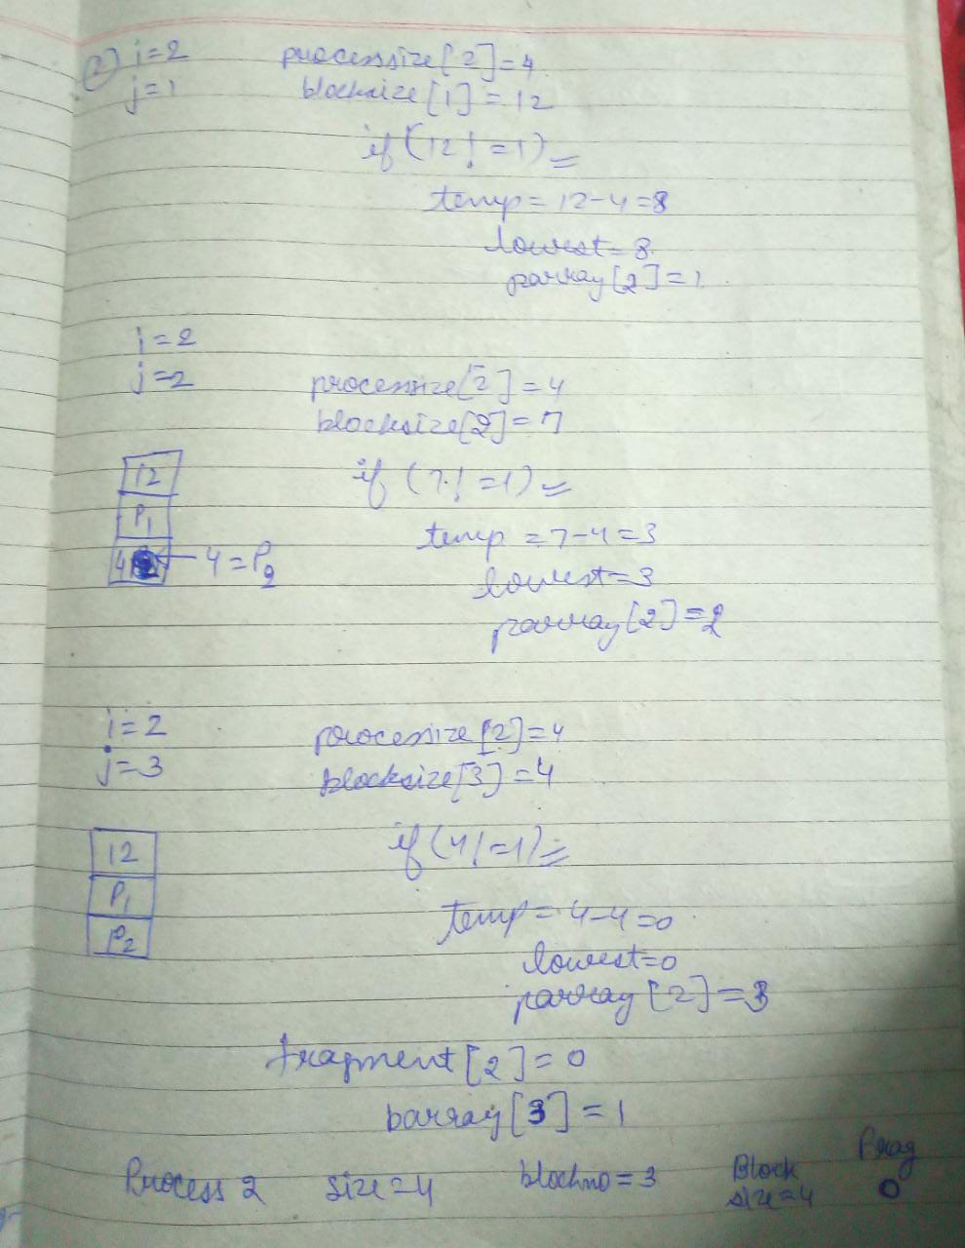

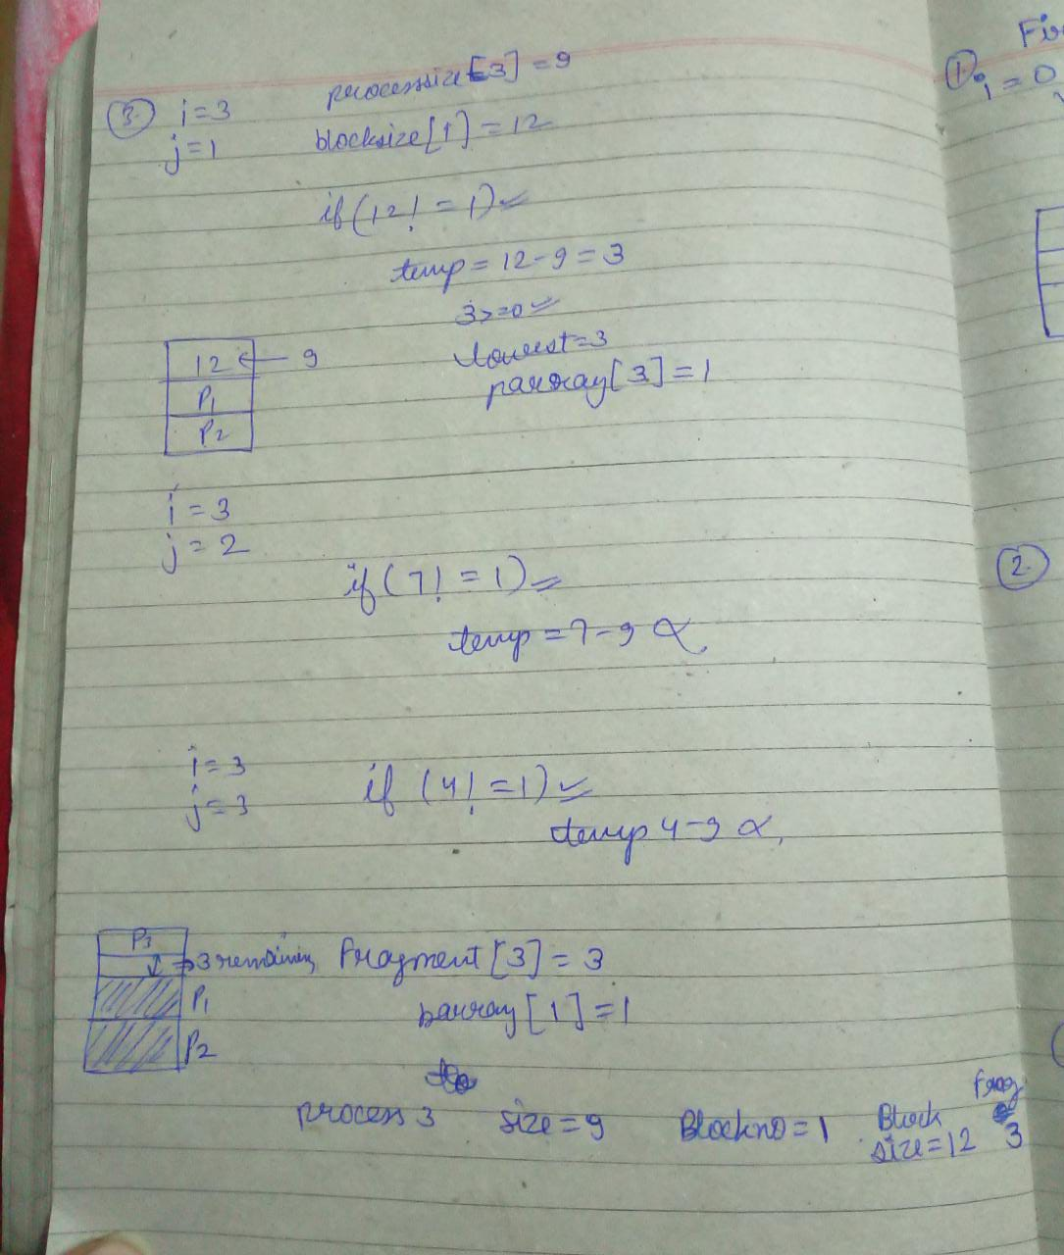

**WORST FIT:-**

#include <iostream>

using namespace std;

int main()

{

int nBlocks,nProcess,blockSize[20],processSize[20];

cout<<"___________Program for Worst fit Algorithm____________________\n";

cout<<"Enter the number of blocks: "; cin>>nBlocks;

cout<<"Enter the number of processes: "; cin>>nProcess;

cout<<"Enter the size of "<<nBlocks<<" blocks:-\n";

for(int i=0;i<nBlocks;i++) cin>>blockSize[i];

cout<<"Enter the size of "<<nProcess<<" processes:-\n";

for(int i=0;i<nProcess;i++) cin>>processSize[i];

for(int i=0;i<nProcess;i++)

{

int max = blockSize[0];

int pos = 0;

for(int j=0;j<nBlocks;j++)

if(max < blockSize[j]) { max = blockSize[j]; pos = j; }

if(max >= processSize[i])

{ cout<<"\nProcess "<<i+1<<" is allocated to block "<<pos+1;

blockSize[pos] = blockSize[pos]-processSize[i];

}

else{ cout<<"\nProcess "<<i+1<<" can't be allocated"; }

}

return 0;

}

**OUTPUT-**

